Linked List:

Basics:
- Linked List is a non linear data structure.
- Data is stored in non contiguous memory location (unlike array).
- Each element is stored in what is called a NODE.
- NODE has two parts:
a) The actual data to be stored.
b) Address of the next element.
- The first node is called the HEAD node.
- The Last node has null stored as address of the next node.

Advantages:

Disadvantages:
- Extra space is required to store the address of the next element.
- We need to traverse each node from the beginning in order to reach to particular node to perform some operation.
- Memory segmentation and memory leak.

Array vs LinkedList:
1. Data access:
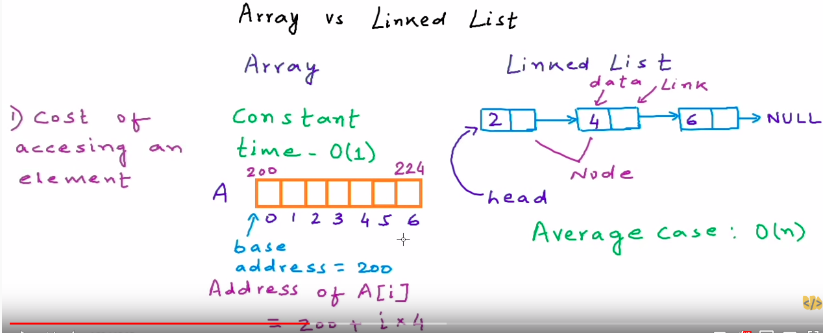

2. Memory requirement:
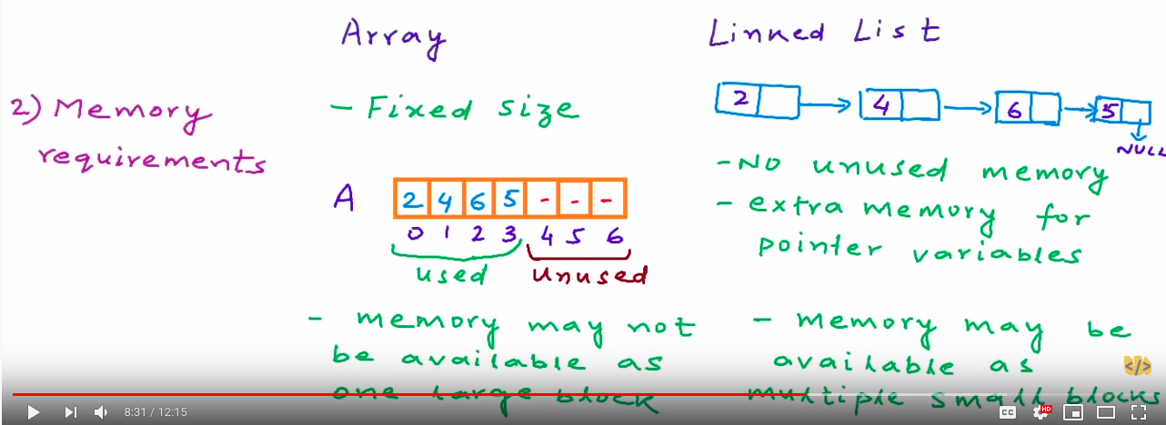

3. Cost of insertion and deletion:
